Electronic Board Design

Abstract
This document describes the design of the electronic board used in the inverter system.

Electronic Board Design 1
Abstract 1
1. Components 2
1.1 Microcontrollers 2
1.1.1 Atmel, AT90PWM3B 2
1.1.2 Arduino Uno 3
1.2 Current Sensors 4
1.3 Power Module 4
1.4 Amplifier 4
1.5 Voltage Regulators 5
2. Circuitry and Schematics 5
2.1 Control Circuit 5
2.1.1 AT90PWM3B version 5
2.1.2 Arduino Version 8
2.2 Power Module Circuit 9
Description of the signals 10
2.3 Feedback Circuit 15
3. Print Circuit Board (PCB) Design 16
2.1 Control Board 16
2.2 Power Module Board 17
2.3 Current sensor board 18
4. Power Loss and Dissipation 18
Conduction loss 18
Switching Loss 19
Reference 21

1. Components

1.1 Microcontrollers

1.1.1 Atmel, AT90PWM3B
Features | Parameters
Number of ADC channels | 11(single-ended)  2 (differential)
ADC Resolution | 10-bit
Clock Speed | 8 MHz (internal RC)  32,64 MHz (internal PLL)
 | 66 MHz (external)
Memory Size | 512 B (SRAM)  512 B (EEPROM)
Flash Size | 8 kB
Number of PWM outputs | 6
Number of Pins | 32
Price (AUD) | 5.67
Table 1 Specs. For AT90PWM3B

Other Features includes
- Three 12-bit High Speed PSC (Power Stage Controllers) for PWM generation
- Non Overlapping Inverted PWM Output Pins With Flexible Dead-Time
- ADC internal reference voltage
- Programmable Serial USART
- Supporting SPI
- 10-bit DAC

AT90PWM3B meets all the requirements while providing additional pros
- Very fast internal clock speed
- Supporting USART (support more peripheral devices)
- Dead time can be implemented with instructions
- PWM generators can produce complementary signals

Development Tools
Tools | Name | Price (AUD)
Programmer | AVR Dragon | 63.00
Starter Kit | STK600 | 258.83
Table 2 Development tools for AT90PWM3B

1.1.2 Arduino Uno
Arduino Uno is a microcontroller board based on the ATmega328.
Features | Parametres
Number of ADC channels | 6(single-ended)
ADC Resolution | 10-bit
Clock Speed | 16 MHz (on board)
Memory Size | 2 kB (SRAM)  1 kB (EEPROM)
Flash Size | 32.5 kB
Number of PWM outputs | 6
Number of Pins | 28
Price (AUD) | 32.00
Table 3 Specs. For Arduino Uno

In addition to the pros and cons of ATmega 328, Arduino Uno is advantageous in several aspects:
- Developed board, minimal circuit design needed
- C-like programming language, simple to code
The most obvious drawback is its lack of flexibility

No additional development tools required

1.2 Current Sensors
Allergro ACS712 Hall Effect Sensor IC
Parameter | Requirements
Sensitivity (mV/A) | 66 - 185
I_{m} (A) | 5 - 30
Frequency (kHz) | 80
PCB mounting | Yes
Max power dissipation (W) | 1200 μΩ internal conductor resistance
Non-Intrusive | Yes
Price (AUD) | 8.13
Table 4 Specs for ACS712

Other Features includes
- Filter pin provides moderate filtration
- Nearly Zero magnetic hysteresis

Two ACS712 current sensors are implemented for the two feedback paths.

1.3 Power Module
FSBB20CH60C
Features | Parametres
V_{CES} (V) | 600
I_{C} (A) 25º | 20
I_{C} (A) 100º | -
Switching Frequency (kHz) | 20
Application Power (kW) | 1.5
Supply Voltage (V) | 450
Control Supply Voltage (V) | 15 - 20
Configurations | Full bridge
Switching Devices | IGBTs
Price (USD) | 29.57

Table 5 Specs for FSBB15CH60F
- Built-in bootstrap diode

1.4 Amplifier
It is suggested that a cascaded differential amplifier should be used. OPA341 from Texas Instrument is chosen.

OPA2341
Features
- Single Supply Operation
- Rail-to-Rail Input
Price (AUD): 2.28

1.5 Voltage Regulators
Voltage Regulators are required to supply various devices:
Voltage (V) | Supplying Device(s) | Voltage Regulator | Price (AUD)
5 V | PIC18F2331;  OPA2341  ACS712 | UA7805CKCS (40 ->5) | 0.58
15 V | FSBB15CH60C; | UA7815CKCS (40 ->15) | 0.61
Table 6 Voltage Regulators

2. Circuitry and Schematics
The system can be categorized into three parts according to their functionalities:
- Control Circuit
- Power Inverter Circuit
- Feedback Circuit

2.1 Control Circuit
The main function of the control circuit is to provide PWM signals to IGBT power module. Two versions of control circuit have been proposed: the first version uses the AVR microcontroller AT90PWM3B mentioned above; the second version uses Arduino ---- a microcontroller board.

2.1.1 AT90PWM3B version
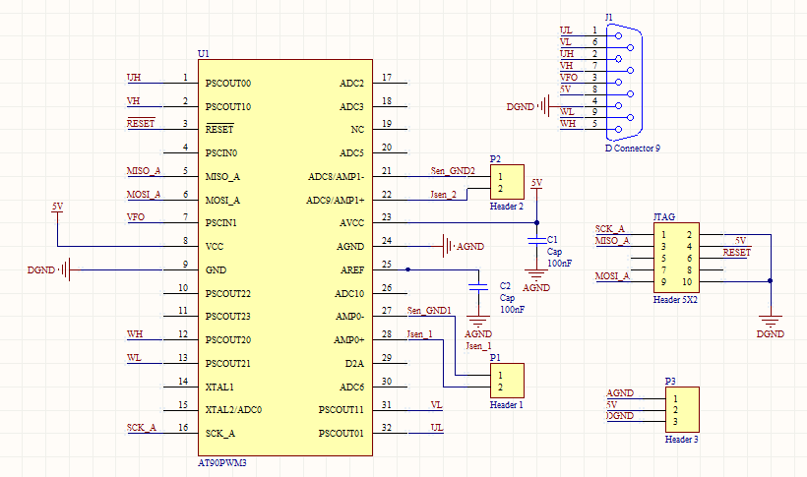

Description of the pins/signals
Pin No. | Pin Name | Signal/Connection | Function
1 | PSCOUT00 | UH | PWM for U phase high-side IGBT
2 | PSCOUT10 | VH | PWM for V phase high-side IGBT
3 | RESET | RESET | RESET from programmer
5 | MISO_A | MISO_A | MISO for programmer
6 | MOSI_A | MOSI_A | MOSI for programmer
7 | PSCIN1 | VFO | Fault signal from Power Module
8 | Vcc | 5V | Power Supply
9 | GND | DGND | Digital Ground
12 | PSCOUT20 | WH | PWM for W phase high-side IGBT
13 | PSCOUT21 | WL | PWM for W phase low-side IGBT
16 | SCK_A | SCK_A | Clock for programmer
21 | AMP1- | Sen_GND2 | Differential ADC ground 2
22 | AMP1+ | Isen_2 | Differential ADC signal 2 (feedback signal)
24 | AGND | AGND | Analog Ground
25 | AREF | Though C2 to AGND | ADC reference voltage 2.56V
27 | AMP0- | Sen_GND1 | Differential ADC ground 1
28 | AMP0+ | Isen_1 | Differential ADC signal 1 (feedback signal)
31 | PSCOUT11 | VL | PWM for V phase low-side IGBT
32 | PSCOUT01 | UL | PWM for U phase low-side IGBT

PWM outputs
Pins: UH, UL, VH, VL, WH and WL

There are six PWM outputs controlling the six switches in IGBT power module. The PWM signals are generated using Power Stage Controller (PSCOUT) within the microcontroller. By writing certain bits to controllers’ registers, we can take control the frequencies and duty cycles of PWM signals.

AT90PWM3B also provides two Timer/Counter modules which can be used as PWM generators. However, the outputs of the modules are limited to four while we need six outputs.

Programming Signals
Pins: RESET, MISO_A, MOSI_A, SCK_A and 5V supply

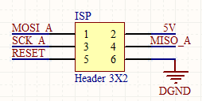
The microcontroller is programmed by a development board called AVR Dragon through its ISP header. The ISP header has a pin out (2.54 mm spacing) as follows
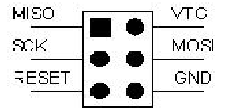

When connecting the AVR Dragon to the target, connect MISO to MISO pin on the target device, MOSI to MOSI. So the connection header on the control circuit board is slightly different, as shown in (b)
The pin functions are shown in the table below, excerpted from ATMEL application note [1]
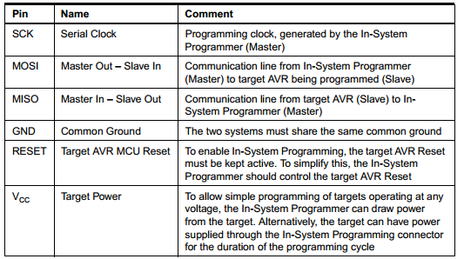

Analog to Digital Pins
Pins: Isen_1, Isen_2, Sen_GND1, Sen_GND2, AGND and AREF

AT90PWM3B has two differential input channels with accurate programmable gain. Those two channels are used for the feedback current from the power module. Differential ADC differs from its single-ended counterparts in that it measures the voltage difference between two pins rather than the difference between one pin and ground. The extra pin provides a more accurate conversion as the grounds for the feedback current are likely to be different.
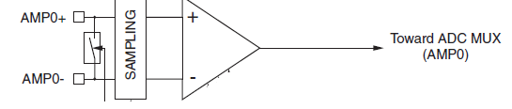

The gain of the amplifier can be set by writing certain values into the control register of ADC. This feature provides a convenient way to scale the feedback current.

FO Input and Power Pins
Pins: FO, DGND, AGND, AREF and 5V

- VFO is the fault signal from Power Module. It is connected to Pin 7 which functions as a GPIO.
- DGND (digital ground) and AGND (analog ground) are separated in the circuit. This separation ensures that digital return currents do not interfere with analog return currents, which will contaminate the analog input signals.
- The analog reference voltage can be supplied internally, so the AREF pin is connected to the ground. It is suggested that the AREF be connected through a capacitor to reject noises.
- The nominal operating power supply of the microcontroller is 5V

2.1.2 Arduino Version

2.2 Power Module Circuit
The power module circuit is designed around the IGBT power module FSBB20CH60F.
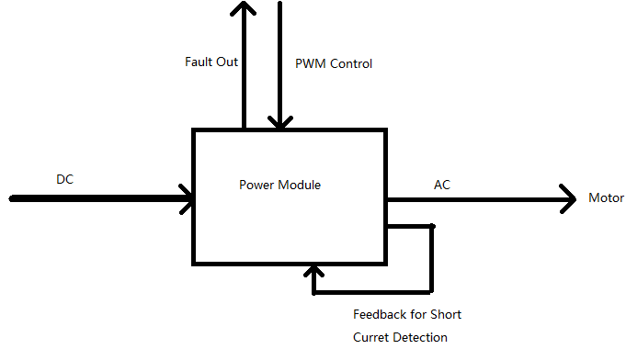

The block diagram above presents the important features of the circuit:
- The power module converts a DC input to an AC output whose frequency is set by the PWM control signals from the control circuit.
- The fault out signal, which is set by the power module, is sent to the controller.
- The current from the low-side of the IGBTs is sensed and feedback to the power module. If a short current occurs, the IGBTs will be disconnected by the ICs in the power module

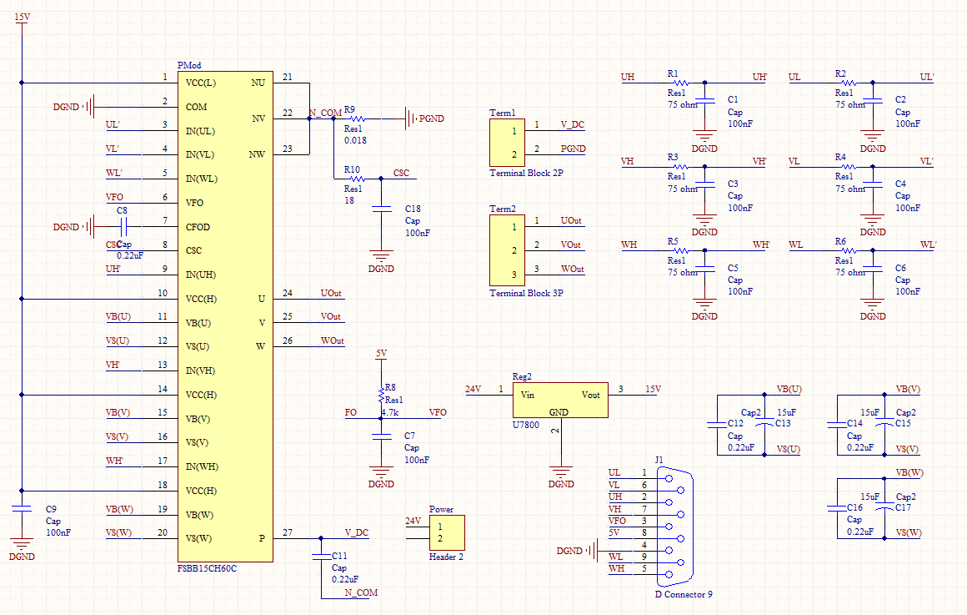
The schematic is shown below

Description of the signals
Pin No. | Pin Name | Signal/Connection | Function
1 | Vcc(L) | 15V | Low-side Common Bias Voltage for IC and IGBTs Driving
2 | COM | DGND | Low-Side Common Supply Ground
3 | IN(UL) | UL’ | Signal Input for Low-Side U Phase
4 | IN(VL) | VL’ | Signal Input for Low-Side V Phase
5 | IN(WL) | WL’ | Signal Input for Low-Side W Phase
6 | VFO | VFO | Fault Output
7 | CFOD | To 0.22uF Capacitor | Capacitor for Fault-output Duration Time Selection
8 | CSC | CSC | Capacitor (Low-pass Filter) for Short-Current Detection Input
9 | IN(UH) | UH’ | Signal Input for High-side U phase
10 | VCC(H) | 15V | High-Side Bias Voltage for U Phase IC
11 | VB(U) | VB(U) | High-Side Bias Voltage for U Phase IGBT Driving
12 | VS(U) | VS(U) | High-Side Bias Voltage Ground for U Phase IGBT Driving
13 | IN(VH) | VH’ | Signal Input for High-side V phase
14 | VCC(H) | 15V | High-Side Bias Voltage for V Phase IC
15 | VB(V) | VB(V) | High-Side Bias Voltage for V Phase IGBT Driving
16 | VS(V) | VS(V) | High-Side Bias Voltage Ground for V Phase IGBT Driving
17 | IN(WH) | WH’ | Signal Input for High-side V phase
18 | VCC(H) | 15V | High-Side Bias Voltage for V Phase IC
19 | VB(W | VB(W) | High-Side Bias Voltage for W Phase IGBT Driving
20 | VS(W) | VS(W) | High-Side Bias Voltage Ground for W Phase IGBT Driving
21 | NU | PGND | Negative DC-Link Input for U Phase
22 | NV | PGND | Negative DC-Link Input for V Phase
23 | NW | PGND | Negative DC-Link Input for W Phase
24 | U | UOut | Output for U Phase
25 | V | VOut | Output for V Phase
26 | W | WOut | Output for W Phase
27 | P | V_DC | Positive DC-Link Input

Signal Inputs
Pins: UH’, UL’, VH’, VL’, WH’ and WL’

These are the six PWM signals from the control circuit. Before entering into the power module, each signal is filtered by a RC filter as shown
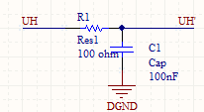
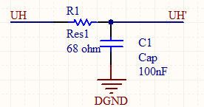

The cut off frequency of the RC filter is 20.9 kHz which is slightly larger than the PWM frequency of 20 kHz.
As specified in the datasheet, signal inputs can be directly coupled to the controller without using any isolation such as an opto-coupler, because the power module provides internal signal isolations.

High-Side Bias Voltage
Pins: VB(U), VS(U), VB(V), VS(V), VB(W) and VS(W)

The bias voltages for IGBTs are supplied by the 15V power supply which is internally connected to the gates. The pins VB and VS are designed for bootstrapping which ensures that the bias voltage is floating in a desirable range (13.5 – 18V) as well as provides high input impedance. The recommended connections are shown below
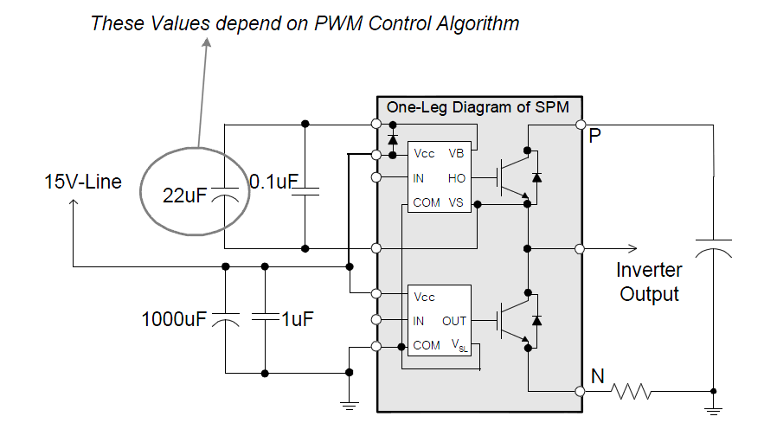

The value of the polarized capacitor (circled in the digram) is determined by the formula
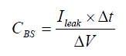

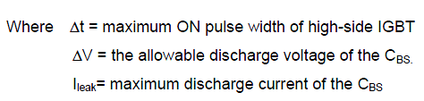

Practically, 1mA of I_{leak} is recommended by the datasheet. The allowable discharge voltage ΔV is set to 1V and the maximum on pulse width of high side IGBT is one PWM switching period which is Δt = 1/20kHz = 0.05 ms. By taking consideration of dispersion and reliability, the capacitance is generally selected to be 2~3 times of the calculated one. Therefore, the capacitor V_{BS} has a value of:
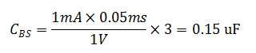

Low-Side Bias Voltage Pin / High-Side Bias Voltage
Pins: VCC(L) and VCC(H)

These pins are the power supply pins for the ICs which control the lower and higher switches. The recommended supply voltage is 15V. In this case, we use a regulator to convert a source voltage of 24V to 15V.

Low-Side Common Supply Ground
Pin: COM

The common pin connects to the control digital ground (DGND) for the internal ICs

Fault Output
Pins: VFO and CFDO

VFO is the fault output pin. VFO is set low if a fault condition occurs in the power module. The fault conditions are SC (short Circuit) or low-side bias UV (Under Voltage) operation. The operation is exemplified below
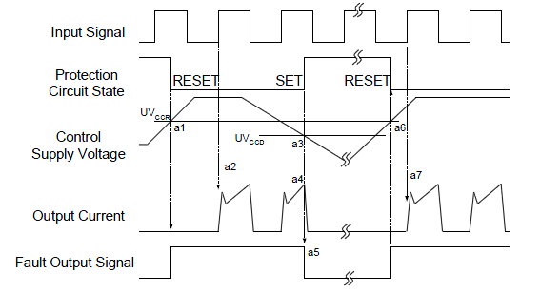

The fault out pulse length T_{FOD} is selected by connecting a capacitor to the pin CFOD. The capacitor value is determined by
If T_{FOD} is set to be 1.8 ms, then C_{FOD} is 33nF

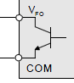
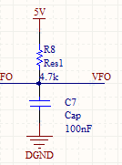
The VFO output is open collector configured, so its collector should be pulled up to the external logic power supply of 5V by a resistor. A 100nF capacitor is also recommended to eliminate noises.

Short Current Detection
Pins: CSC

Line current on the N side of DC-link is sensed and protective operation signal is passed through the RC filter to the power module. If the current exceeds the preset reference level (e.g. short current), all the gates of the low side three-phase IGBTs are switched off and the FO fault signal is transmitted to the CPU.

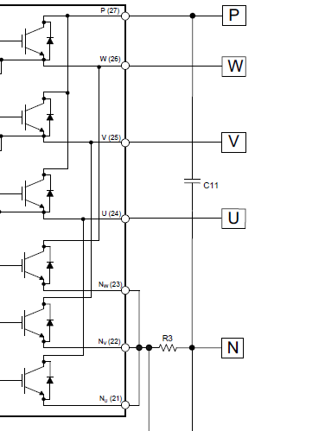

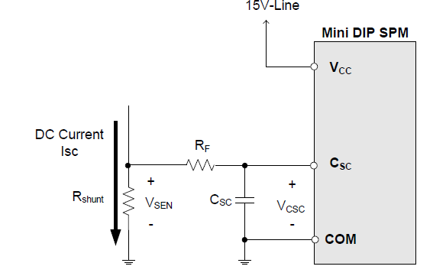

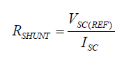
The current is sensed by a single resistor R_{SHUNT} given by

where V_{SC(REF)} is the short circuit reference voltage having a fixed value of 0.5 V

The short circuit current magnitude is dependant on gate voltage applied. A higher gate voltage results in a larger short circuit current. To avoid this potential problem, the datasheet suggests that the maximum short circuit trip level be set to below 1.7 times the nominal rated collector current (20A). In this case, we have chosen a factor of 1.5. Therefore, R_{SHUNT} is evaluated to be 0.0167 ohms. A resistor of 0.018 ohms is chosen, which gives a short current of 27.78A.

Next, we need to determine the resistor value R_{F} and capacitor value C_{SC} in the RC filter for CSC signal. The datasheet suggests that the RC time constant be 1.5 ~ 2 μs. Using a time constant of 1.8 μs, we can use a C_{SC} value of 100 nF and R_{F} value of 18 ohms.

Let t₁ be the filter delay time (t1) of 1.8 μs; t₂ be the internal noise elimination logic filter delay (t2) of 0.5 μs and t₃ be the IC transfer time delay of 0.9 μs. The total time from the detection of the SC trip current to the gate off of the IGBT can be evaluated by

DC-Link Pins
Pins: P, NU, NV and NW.

P is the DC-link positive power supply pin of the inverter, which is connected to the collectors of the high-side IGBTs.
NU, NV and NW are the DC-link negative power supply pins (power ground) of the inverter. These pins are connected to the low-side IGBT emitters of the each phase.
The DC input and DC power ground (PGND) are provided (presumably) by the DC supply of the machine in which the inverter system is to be installed.

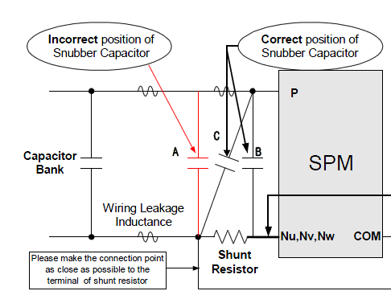
A snubber capacitor is used to protect the power module from excessive surge. A 0.22uF capacitor connects the DC input (V_DC) and the common terminal of NU, NV and NW as shown below (Location B)

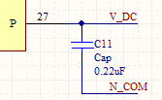

It is suggested in the user’s guide that snubber capacitor connected in location B provides greater surge suppression than in location C. If installed in location A, the snubber capacitor cannot suppress the surge voltage effectively.

Inverter Power Output Pin
Pins: U, V and W

These are the inverter output pins for connecting to the motor.

2.3 Feedback Circuit
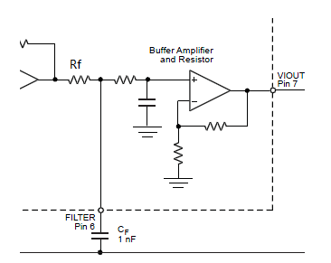
As shown in the figure below, ACS712 current sensor provides a mean of filtration through its internal filter resistor Rf, internal buffer amplifier and a filter pin. The filter pin is connected to an external capacitor Cf selected by user. The buffer eliminates the attenuation caused by the resistive divider effect which causes considerable attenuation

The output of the inverter system is designed to have a maximum frequency of 400 Hz. However, the actual frequency might be greater or smaller than the designed frequency. In this case, it is reasonable to set the cut-off frequency of low-pass filter for the feedback current to 800 Hz.
With Rf fixed at a value of 1.7kΩ, the value of capacitor is given by
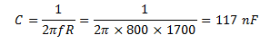

Therefore, a 100nF capacitor giving us a cut-off frequency of 936 Hz would suffice.

3. Print Circuit Board (PCB) Design

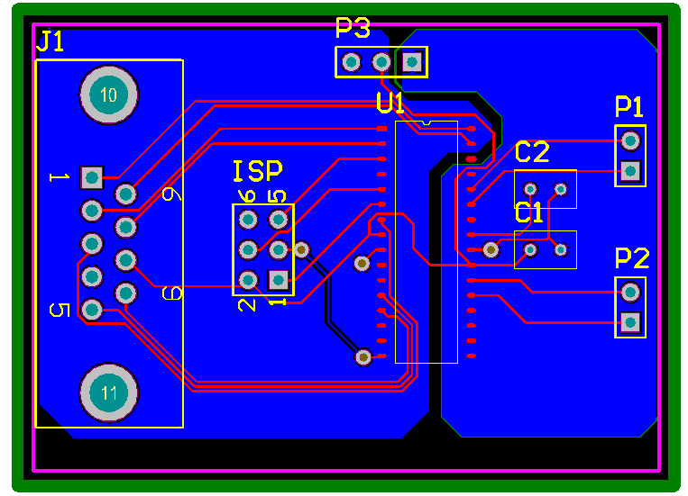
2.1 Control Board

Because D-subminiature (J1) cables are more robust, they are used to link the control board to power module board.
Groud planes are implemented on the bottom layer. The ground planes have much lower impedance because of their large cross-sectional area. This effectively reduces the EMI because the currents are able to circulating back to the source much easier. In addition, the anolog groud plane is seperated from the digital ground plane by a 1-mm gap. This highly reduces the interferences between digital signals and analog signals.

2.2 Power Module Board
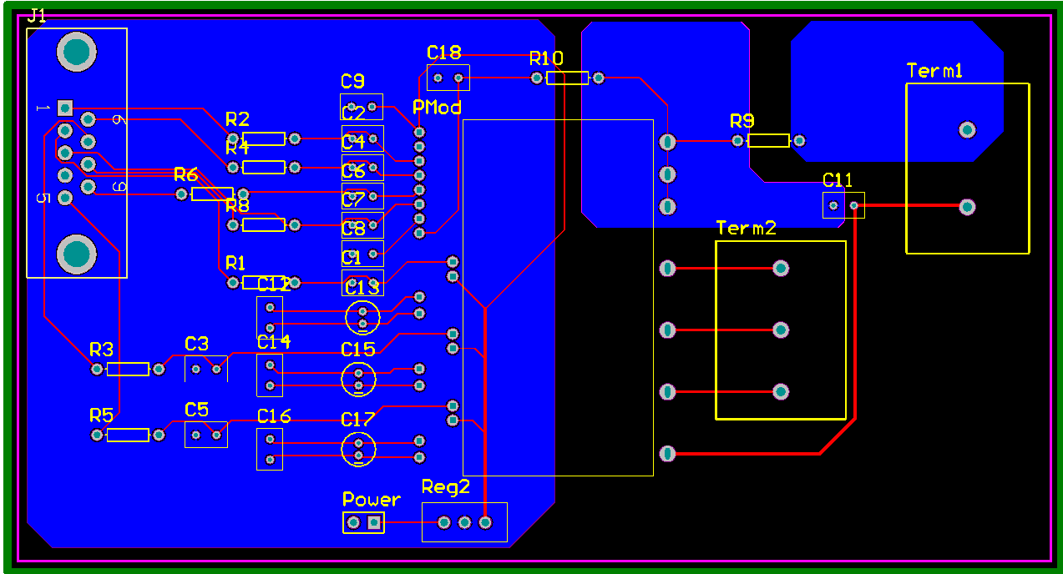

Filtration capacitors for the input signals and fault output are placed close to the power module.
Three planes are designed for DGND, power ground (PGND) and the negative power supply pins (Nx). The Nx plane minimizes the impedance between the shunt resistor R9 and the DC supply circuit.

2.3 Current sensor board

4. Power Loss and Dissipation
The power module has six switching units, each of which consists of one IGBT and one anti-parallel diode. Two major contributors of power loss for these semiconductors are conduction and switching loss. The loss turn-off steady state loss can be ignored.

Conduction loss ^{[2]}
The output current of the PWM-inverter can be assumed to be sinusoidal with a peak value
where is the phase-angle difference between output voltage and current, is the phase angle of the voltage.

The conduction loss of one IGBT is
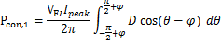
where is the forward voltage of the IGBT and D is the duty cycle

The conduction loss of one diode is
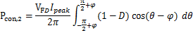
where is the forward voltage of the bootstrapping diode

The duty cycle at a given can be obtained by
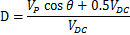
where is the peak of the output phase voltage and V_{DC} is the DC link voltage

Eventually, the total conduction losses is given by

Assume
The datasheet specifies that the forward drop voltages of IGBTs are 2.2 V when they conduct 20A current. and the forward drop voltage of antiparallel diodes is typically 2.5V. V_{DC} and V_{p} are 。。。。。。
Therefore, the total conduction loss for six switching units is

Switching Loss ^{[2]}
The switching energy losses L of the IGBTs and diodes can be calculated using the linear equations
where, Eon is the switching loss (on) characteristic and Eoff is the switching loss (off) characteristic of the switching units.

The values of the switching loss characteristics can be found in the datasheet
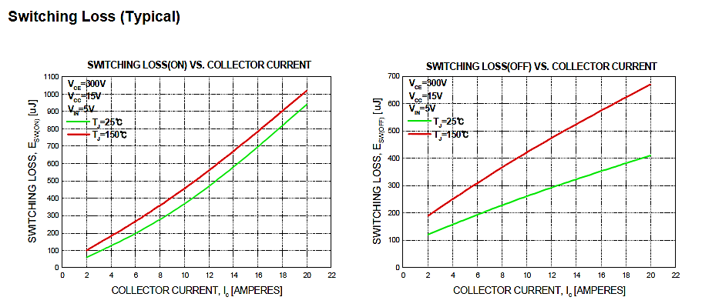
Similar to the calculation of conduction loss, the output current of the PWM-inverter can be assumed to be sinusoidal with a peak value

The conduction loss of one IGBT and one diode is
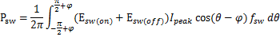
where f_{sw} is the switching frequency

By integration, we have
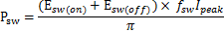

With a temperature of and a collector current of ……, we can find switching loss to be 。。。. Hence, the switching loss for six switching units is

Reference
[1] AVR910: In-System Programming, Atmel Corporation, 2008
[2] Application Note AN-9044, Fairchild Semiconductor, 2008
[3] SPM Module Design Guide, Fairchild Semiconductor, 2012

2. From Australia Robotics

